|  |
| --- |
| J-N STUDIO |
| MAP REVIEW |
| Version 1.0 |
|  |
| **John** |
| **26/01/2018** |

|  |
| --- |
| This document is shared within the studio and studio only |

Contents

# I/ MAP BUILDING SPEC:

## 1/ Map outline:

The Map is lay out by John, the idea was island city got quarantined so that the city can have multiple ways for the player to escape:

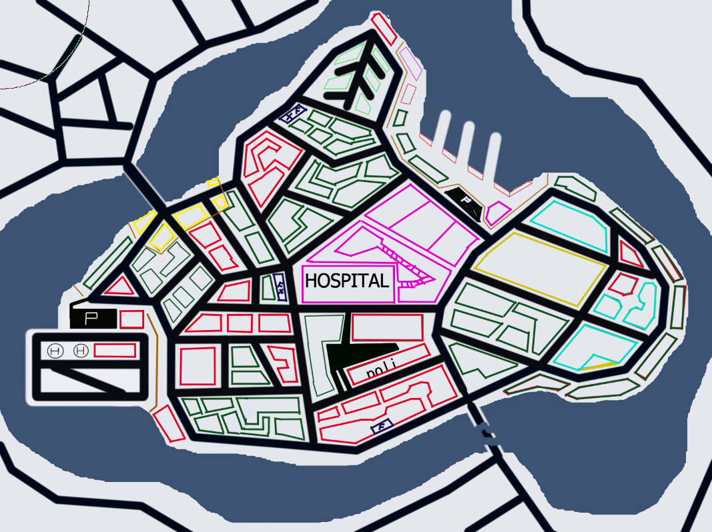

The map would require a lot of space so that we can have big and tall buildings to create alley ways and park area, hospital and parking lot for police and firefighter then the scale must not be small, This the green light would be equal 7 km in length to accommodate all of the features of the city:

* 3 fuel station( F dark navy spots)
* 1 airport (south west, with 2 H circle for helipads)
* 1 ship yard(north east point, with 3 concrete shaft)
* 1 military area (bright yellow)
* One big medical compound include hospital and laboratory (purple)
* Police station, fire department, city hall (bellow hospital (there are 3 buildings with parking lot.
* A park (brown yellow)
* Shopping malls (light blue)
* Stores (red)
* Houses (green)
* Expensive house / villas (bright green)
* ?? a school of some sort in the city south

## 2/Map details:

## 2.1/Road work:

- Road is part of the city so assets for road will be plenty full, a basic set of roads and street set.

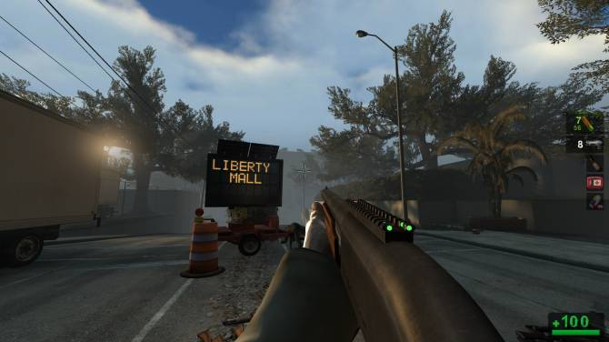

- To enhance the look of the street that is war torn or of the wreck(newspaper, dying leaves, water) decal or cracked decal. Can put small simple plane with images of torn

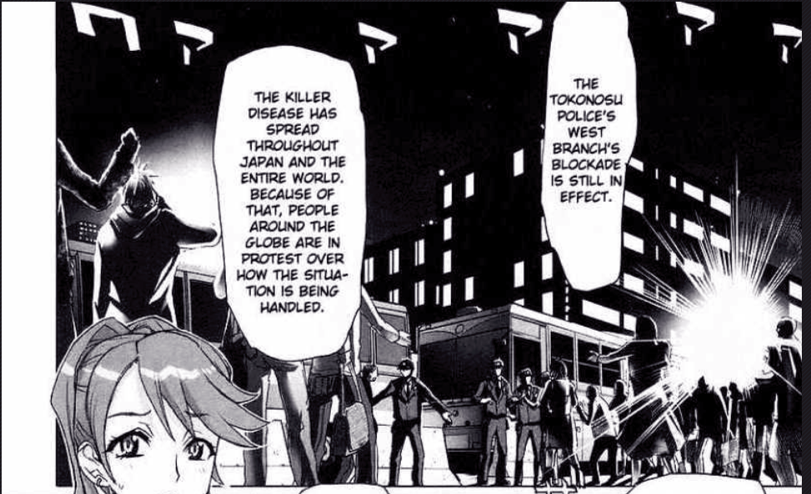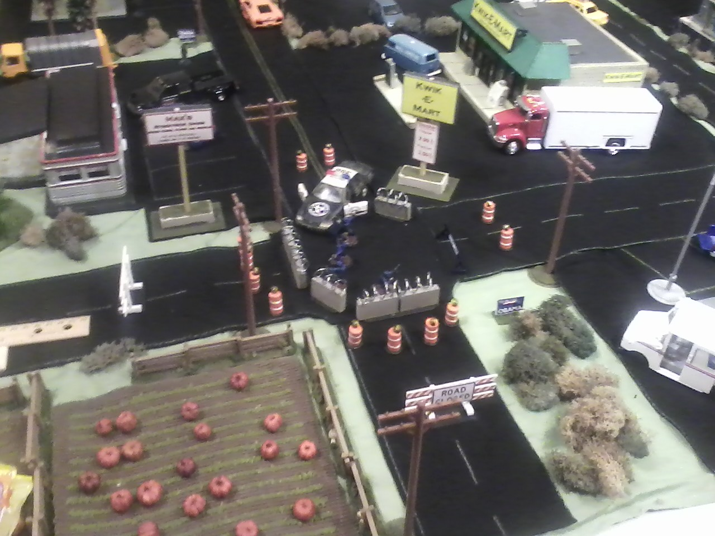

- Since it is an apocalypse setting, there are broken cars and vehicles and blockages on the street. Next to blockages of course should be metal crowd fences,police car, ambulances (both normal with dirty decal and broken models can be used here) to establish the ground that the police and government were running check points.

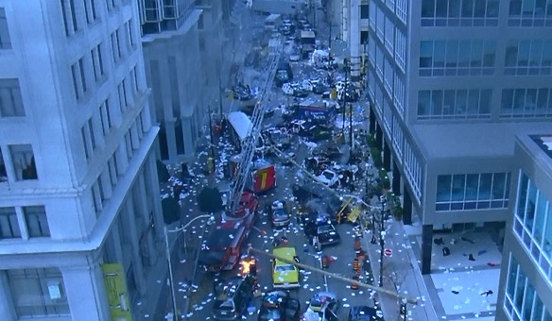

## 2.2/ shopping mall:

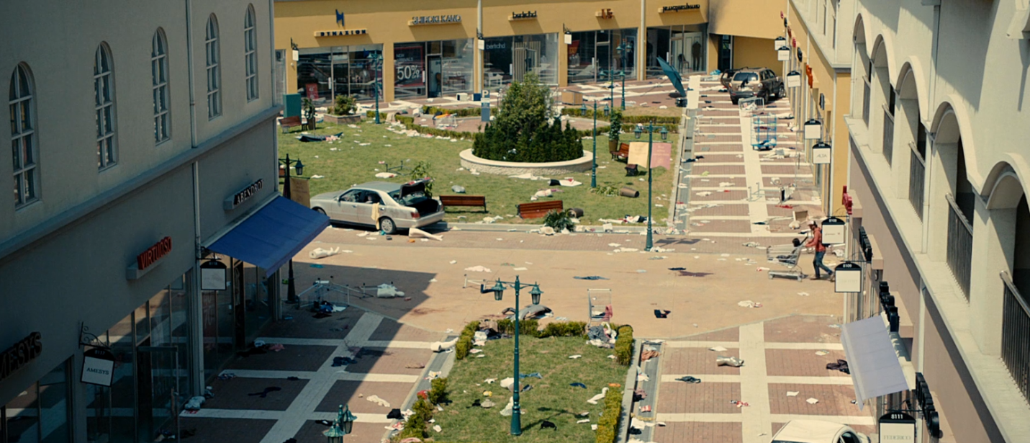

* shopping area is slightly desert with car over run to the inside, and big supermarkets with NO ENTRY. Player can roam around the area but NOT INSIDE THE BUILDING.
* he malls can be inspired by this “I AM HERO” 2012 movie scene, the mall is deem empty, but the zombie is lurking around and in hibernated mode.

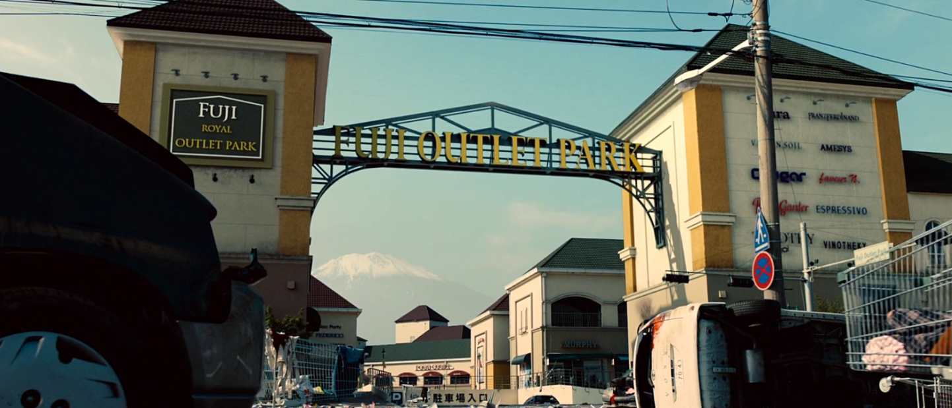

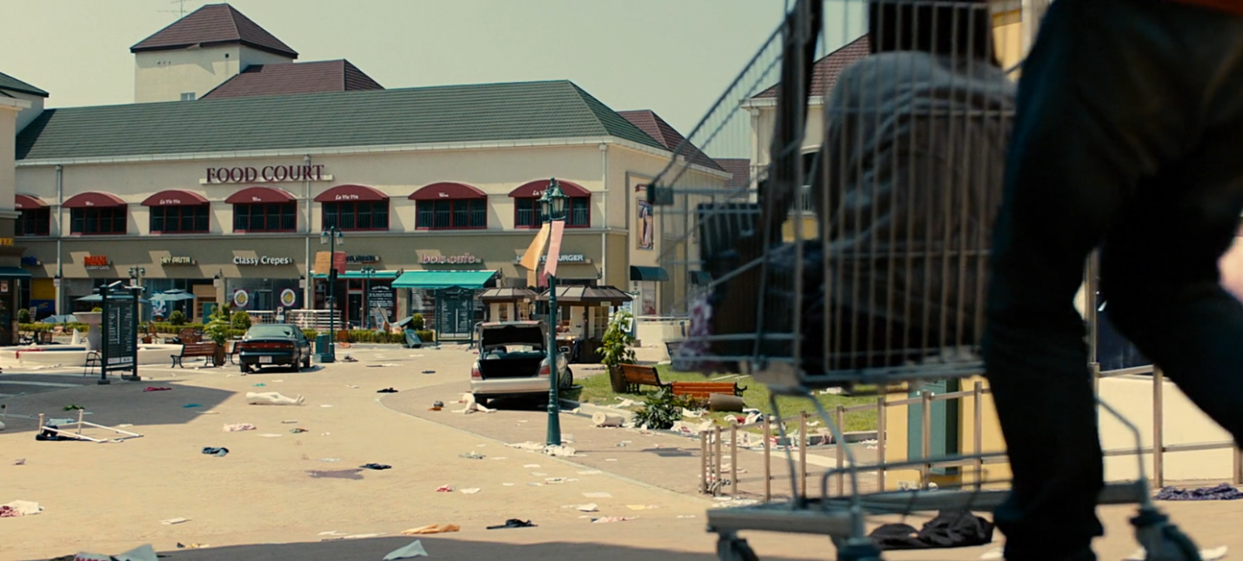

## 2.3/ Military Compound:

- The military compound contains military trucks, as they locked the gate to the northern bridge so there should be a fortified gate.

- Military hardwares (buildings,props and vehicle) is already aquired in the models set so that won’t be so hard to layed out.

- The compound must have raised platform to allow soldiers to patrol on them.

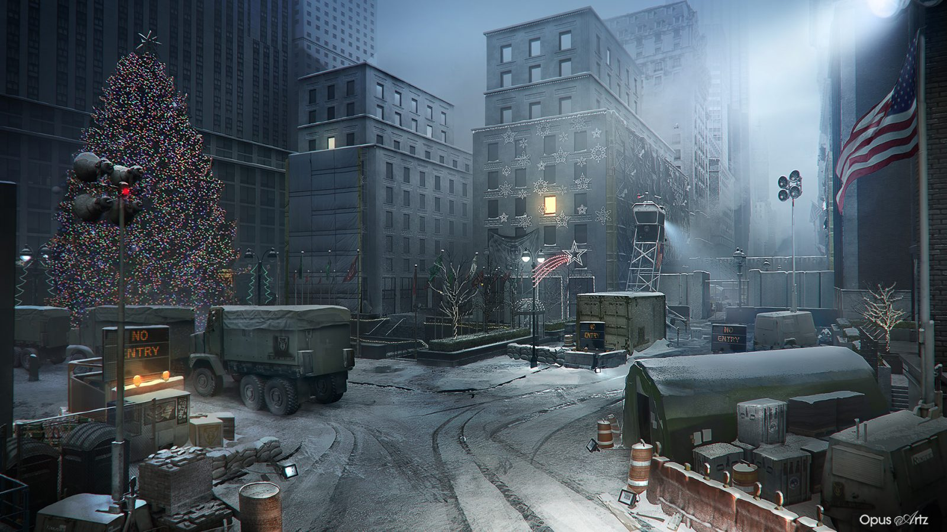

## 2.4/Fuel station:

- One of the key locations for our character gather key items, FUEL, to escape.

- Vietnamese fuel station should be around the same size, but you can get creative any way

# 3/ Zombie apocalypse movie and game scene

